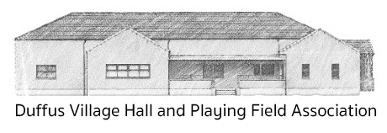
Scottish Charity SC014059
APPLICATION FOR HIRE
(BLOCK CAPITALS PLEASE)

Name | Click or tap here to enter text.
Address | Click or tap here to enter text. |  |  |  | Telephone | Click or tap here to enter text.
Address |  |  |  |  | Mobile | Click or tap here to enter text.
Address |  |  |  |  | Postcode | Click or tap here to enter text.
Email | Click or tap here to enter text.
Details of the hire (tick as appropriate):
 | ☐ Wedding (all Halls) |  | ☐ Main Hall | ☐ Lesser Hall |  | ☐ Meeting Room
Date (from) | Click or tap to enter a date. |  |  | Date (to) |  | Click or tap to enter a date.
Time (from) | Click or tap here to enter text. |  |  | Time (to) |  | Click or tap here to enter text.
For the purpose of |  | Click or tap here to enter text.
Alcohol Licence
A license for the sale of excisable liquor |  |  | ☐ will be applied for |  |  | ☐ will not be applied for
Comments/Questions
Click or tap here to enter text.
Acceptance of Terms
☐ I/We have read and understood a copy of the Conditions of Hire etc. and agree to abide by
the rules laid down therein.
Data Consent
The data provided on this form will be retained by the Hall Booking Secretary and the Treasurer for the duration of the hire and until full payment has been made.
☐ I/We consent to the details above being circulated within the Duffus Village Hall and Playing Field
Association as stated above.
Signed | Click or tap here to enter text. |  |  |  |  | Date | Click or tap to enter a date.
On behalf of | Click or tap here to enter text.
The completed booking form should be returned as soon as possible to:
Duffus Hall Booking Secretary, 15 Northfield, Duffus, Elgin, Moray. IV30 5RW
Tel. 01343 835464. Email enquiries@duffusvillagehall.co.uk

